évaluation Entretenir le logement

Et le linge d’un particulier

**Nom, Prénom du stagiaire :**

**Intitulé de la formation : CCP1 Entretenir le logement**

Déroulement :

Vous avez 5 heures pour réaliser votre évaluation

Il n’y aura pas de pause pendant l’évaluation

Il est important de bien lire les consignes

|  |
| --- |
| **APPRÉCIATION DU FORMATEUR :** |
| * _ _ _ _ _ _ _ _ _ _ _ _ _ _ _ _ _ _ _ _ _ _ _ _ _ _ _ _ _ _ _ _ _ _ _ _ _ _ _ _ _ _ _ _ _ _ _ _ _ _ _ _ _ _ _ _ _ _ _ _ _ * _ _ _ _ _ _ _ _ _ _ _ _ _ _ _ _ _ _ _ _ _ _ _ _ _ _ _ _ _ _ _ _ _ _ _ _ _ _ _ _ _ _ _ _ _ _ _ _ _ _ _ _ _ _ _ _ _ _ _ _ _ * _ _ _ _ _ _ _ _ _ _ _ _ _ _ _ _ _ _ _ _ _ _ _ _ _ _ _ _ _ _ _ _ _ _ _ _ _ _ _ _ _ _ _ _ _ _ _ _ _ _ _ _ _ _ _ _ _ _ _ _ _ * _ _ _ _ _ _ _ _ _ _ _ _ _ _ _ _ _ _ _ _ _ _ _ _ _ _ _ _ _ _ _ _ _ _ _ _ _ _ _ _ _ _ _ _ _ _ _ _ _ _ _ _ _ _ _ _ _ _ _ _ _ * _ _ _ _ _ _ _ _ _ _ _ _ _ _ _ _ _ _ _ _ _ _ _ _ _ _ _ _ _ _ _ _ _ _ _ _ _ _ _ _ _ _ _ _ _ _ _ _ _ _ _ _ _ _ _ _ _ _ _ _ _ |

**Corrigé**

**Quelle est l’importance d’entretenir le logement ou le lieu de vie de la personne aidée ?**

* Cela permet à la Personne Aidée, de se sentir bien chez elle
* De ne pas être perdue et démoralisée
* De pouvoir garder les habitudes de vie de la Personne Aidée
* _ _ _ _ _ _ _ _ _ _ _ _ _ _ _ _ _ _ _ _ _ _ _ _ _ _ _ _ _ _ _ _ _ _ _ _ _ _ _ _ _ _ _ _ _ _ _ _ _ _ _ _ _ _ _ _ _ _ _
* _ _ _ _ _ _ _ _ _ _ _ _ _ _ _ _ _ _ _ _ _ _ _ _ _ _ _ _ _ _ _ _ _ _ _ _ _ _ _ _ _ _ _ _ _ _ _ _ _ _ _ _ _ _ _ _ _ _ _
* _ _ _ _ _ _ _ _ _ _ _ _ _ _ _ _ _ _ _ _ _ _ _ _ _ _ _ _ _ _ _ _ _ _ _ _ _ _ _ _ _ _ _ _ _ _ _ _ _ _ _ _ _ _ _ _ _ _ _

**Quelle est la particularité de l’utilisation d’une microfibre au lieu d’un chiffon normal ?**

* Cela permet d’agglutiner les poussières et de ne pas les laisser s’envoler.
* _ _ _ _ _ _ _ _ _ _ _ _ _ _ _ _ _ _ _ _ _ _ _ _ _ _ _ _ _ _ _ _ _ _ _ _ _ _ _ _ _ _ _ _ _ _ _ _ _ _ _ _ _ _ _ _ _ _ _
* _ _ _ _ _ _ _ _ _ _ _ _ _ _ _ _ _ _ _ _ _ _ _ _ _ _ _ _ _ _ _ _ _ _ _ _ _ _ _ _ _ _ _ _ _ _ _ _ _ _ _ _ _ _ _ _ _ _ _
* _ _ _ _ _ _ _ _ _ _ _ _ _ _ _ _ _ _ _ _ _ _ _ _ _ _ _ _ _ _ _ _ _ _ _ _ _ _ _ _ _ _ _ _ _ _ _ _ _ _ _ _ _ _ _ _ _ _ _
* _ _ _ _ _ _ _ _ _ _ _ _ _ _ _ _ _ _ _ _ _ _ _ _ _ _ _ _ _ _ _ _ _ _ _ _ _ _ _ _ _ _ _ _ _ _ _ _ _ _ _ _ _ _ _ _ _ _ _
* _ _ _ _ _ _ _ _ _ _ _ _ _ _ _ _ _ _ _ _ _ _ _ _ _ _ _ _ _ _ _ _ _ _ _ _ _ _ _ _ _ _ _ _ _ _ _ _ _ _ _ _ _ _ _ _ _ _ _

**Quelle est votre organisation dans l’entretien du logement, par quoi allez-vous commencer ?**

* Je vais commencer en Priorisant les attentes de la personne Aidée.
* Je priorise selon l’importance des tâches à effectuer
* _ _ _ _ _ _ _ _ _ _ _ _ _ _ _ _ _ _ _ _ _ _ _ _ _ _ _ _ _ _ _ _ _ _ _ _ _ _ _ _ _ _ _ _ _ _ _ _ _ _ _ _ _ _ _ _ _ _ _
* _ _ _ _ _ _ _ _ _ _ _ _ _ _ _ _ _ _ _ _ _ _ _ _ _ _ _ _ _ _ _ _ _ _ _ _ _ _ _ _ _ _ _ _ _ _ _ _ _ _ _ _ _ _ _ _ _ _ _
* _ _ _ _ _ _ _ _ _ _ _ _ _ _ _ _ _ _ _ _ _ _ _ _ _ _ _ _ _ _ _ _ _ _ _ _ _ _ _ _ _ _ _ _ _ _ _ _ _ _ _ _ _ _ _ _ _ _ _
* _ _ _ _ _ _ _ _ _ _ _ _ _ _ _ _ _ _ _ _ _ _ _ _ _ _ _ _ _ _ _ _ _ _ _ _ _ _ _ _ _ _ _ _ _ _ _ _ _ _ _ _ _ _ _ _ _ _ _
* _ _ _ _ _ _ _ _ _ _ _ _ _ _ _ _ _ _ _ _ _ _ _ _ _ _ _ _ _ _ _ _ _ _ _ _ _ _ _ _ _ _ _ _ _ _ _ _ _ _ _ _ _ _ _ _ _ _ _
* _ _ _ _ _ _ _ _ _ _ _ _ _ _ _ _ _ _ _ _ _ _ _ _ _ _ _ _ _ _ _ _ _ _ _ _ _ _ _ _ _ _ _ _ _ _ _ _ _ _ _ _ _ _ _ _ _ _ _
* _ _ _ _ _ _ _ _ _ _ _ _ _ _ _ _ _ _ _ _ _ _ _ _ _ _ _ _ _ _ _ _ _ _ _ _ _ _ _ _ _ _ _ _ _ _ _ _ _ _ _ _ _ _ _ _ _ _ _
* _ _ _ _ _ _ _ _ _ _ _ _ _ _ _ _ _ _ _ _ _ _ _ _ _ _ _ _ _ _ _ _ _ _ _ _ _ _ _ _ _ _ _ _ _ _ _ _ _ _ _ _ _ _ _ _ _ _ _
* _ _ _ _ _ _ _ _ _ _ _ _ _ _ _ _ _ _ _ _ _ _ _ _ _ _ _ _ _ _ _ _ _ _ _ _ _ _ _ _ _ _ _ _ _ _ _ _ _ _ _ _ _ _ _ _ _ _ _
* _ _ _ _ _ _ _ _ _ _ _ _ _ _ _ _ _ _ _ _ _ _ _ _ _ _ _ _ _ _ _ _ _ _ _ _ _ _ _ _ _ _ _ _ _ _ _ _ _ _ _ _ _ _ _ _ _ _ _

**Une surface plane, une table, une vitre, un cadre, une porte, comment allez-vous nettoyer ?**

* Pour une table, je pulvérise le produit sur le chiffon (meuble à l’horizontal)
* Pour une vitre, je pulvérise sur la vitre (meuble à la vertical)
* _ _ _ _ _ _ _ _ _ _ _ _ _ _ _ _ _ _ _ _ _ _ _ _ _ _ _ _ _ _ _ _ _ _ _ _ _ _ _ _ _ _ _ _ _ _ _ _ _ _ _ _ _ _ _ _ _ _ _
* _ _ _ _ _ _ _ _ _ _ _ _ _ _ _ _ _ _ _ _ _ _ _ _ _ _ _ _ _ _ _ _ _ _ _ _ _ _ _ _ _ _ _ _ _ _ _ _ _ _ _ _ _ _ _ _ _ _ _
* _ _ _ _ _ _ _ _ _ _ _ _ _ _ _ _ _ _ _ _ _ _ _ _ _ _ _ _ _ _ _ _ _ _ _ _ _ _ _ _ _ _ _ _ _ _ _ _ _ _ _ _ _ _ _ _ _ _ _
* _ _ _ _ _ _ _ _ _ _ _ _ _ _ _ _ _ _ _ _ _ _ _ _ _ _ _ _ _ _ _ _ _ _ _ _ _ _ _ _ _ _ _ _ _ _ _ _ _ _ _ _ _ _ _ _ _ _ _

**Expliquez l’entretien de cette table, comment la nettoyez-vous. Schématiser sur le dessin.**

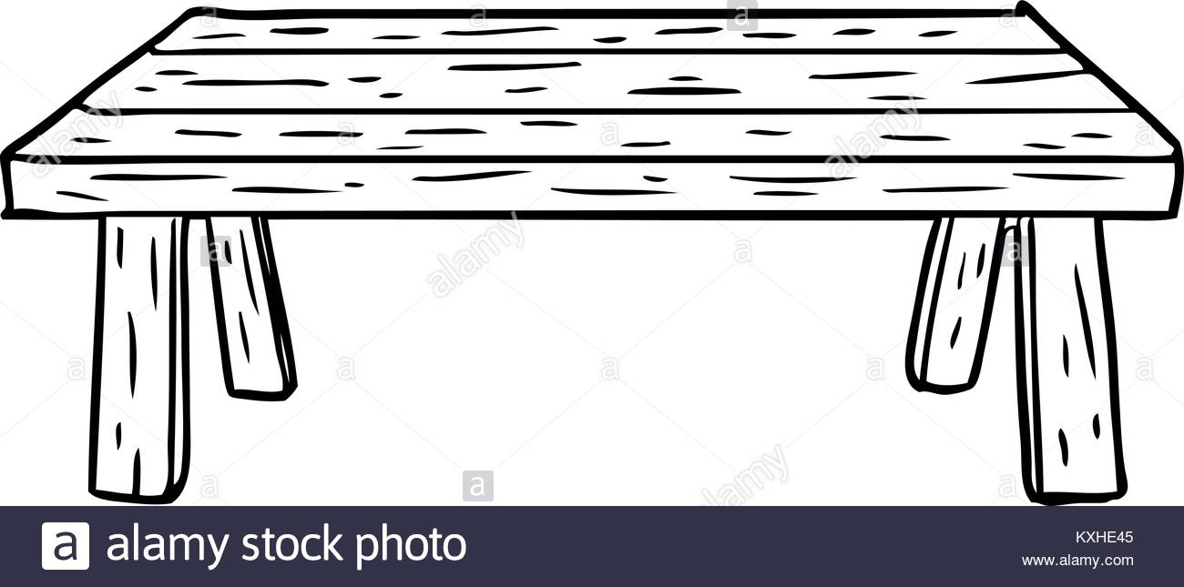

* Je pulvérise mon produit sur la microfibre, (chiffon, chiffonnette, etc.)
* Je fais le détourage de la table
* Je fais toute la surface en S ou en 8
* Je nettoie les pieds du haut en bas.
* _ _ _ _ _ _ _ _ _ _ _ _ _ _ _ _ _ _ _ _ _ _ _ _ _ _ _ _ _ _ _ _ _ _ _ _ _ _ _ _ _ _ _ _ _ _ _ _ _ _ _ _ _ _ _ _ _ _ _

**Décrivez-moi les étapes :**

**Expliquez l’entretien de ce miroir, comment le nettoyez-vous. Schématiser sur le dessin.**

**Décrivez-moi les étapes :**

* Je mets du produit à vitre sur le miroir et à l’aide d’un chiffon, je fais le détourage et ensuite je fais des mouvements circulaires en S ou en 8
* Je prends une chiffonnette sèche pour essuyer en faisant des mouvements en S ou en 8 pour effacer les dernières traces.
* _ _ _ _ _ _ _ _ _ _ _ _ _ _ _ _ _ _ _ _ _ _ _ _ _ _ _ _ _ _ _ _ _ _ _ _ _ _
* _ _ _ _ _ _ _ _ _ _ _ _ _ _ _ _ _ _ _ _ _ _ _ _ _ _ _ _ _ _ _ _ _ _ _ _ _ _

**Expliquez l’entretien de ce lavabo, comment le nettoyez-vous. Schématiser sur le dessin.**

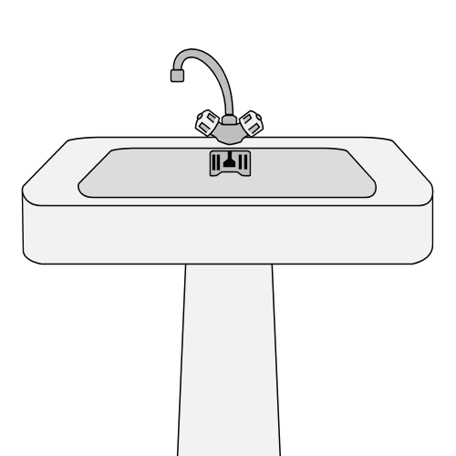**Décrivez-moi les étapes :**

* 1) je pulvérise le produit détartrant, je laisse agir quelques minutes.
* 2) Je commence par le contour, les flancs, le pied, je fais l’intérieur du lavabo.
* 3) Je termine par la robinetterie, en finissant par les poignets.
* _ _ _ _ _ _ _ _ _ _ _ _ _ _ _ _ _ _ _ _ _ _ _ _ _ _ _ _ _ _ _ _ _ _ _ _ _ _ _ _ _
* _ _ _ _ _ _ _ _ _ _ _ _ _ _ _ _ _ _ _ _ _ _ _ _ _ _ _ _ _ _ _ _ _ _ _ _ _ _ _ _ _
* _ _ _ _ _ _ _ _ _ _ _ _ _ _ _ _ _ _ _ _ _ _ _ _ _ _ _ _ _ _ _ _ _ _ _ _ _ _ _ _ _
* _ _ _ _ _ _ _ _ _ _ _ _ _ _ _ _ _ _ _ _ _ _ _ _ _ _ _ _ _ _ _ _ _ _ _ _ _ _ _ _ _

**Expliquez l’entretien de ce toilette, comment le nettoyez-vous. Schématiser sur le dessin**.

**Décrivez-moi les étapes :**

* Mettre le réceptacle dans une eau avec un produit désinfectant.
* Je mets un produit détartrant dans les toilettes
* Je nettoie la cuvette avec la brosse
* Je laisse la brosse dans les toilettes après avoir nettoyé la cuvette
* Je nettoie la chasse d’eau sans toucher le bouton de la chasse
* Je nettoie le couvercle et la lunette recto/verso et le bord des toilettes.
* Je nettoie le pied du toilette, du haut vers le bas
* Je nettoie le bouton de la chasse d’eau, les poignées de porte et l’interrupteur.
* Je nettoie et je range mon matériel

**Quels sont ses produits ; quelle est leur efficacité ; où les utiliser ?**



Détartrant 🡺 Cuvette des WC

Déboucheur / Corosif 🡺 Canalisation

Désinfectant Fraicheur 🡺 Cuvette des WC



Détergeant / Protecteur 🡺 Carrelage

Détergeant / Désincrustant 🡺 Multi surface

Détergeant / désincrustant 🡺 Vitre et Miroir

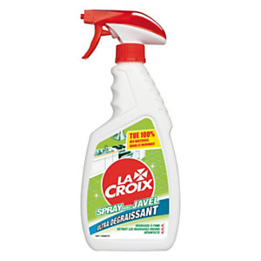**Quels sont ses produits ; quelle est leur efficacité ; où les utiliser ?**

Détartrant 🡺 Cuisine et Salle de Bain et Machine à laver

Désinfectant 🡺 Toutes surfaces et tous objets

Corrosif / Dégraissant / désinfectant / Blanchisseur 🡺 Cuisine / Salle de Bain et plan de travail

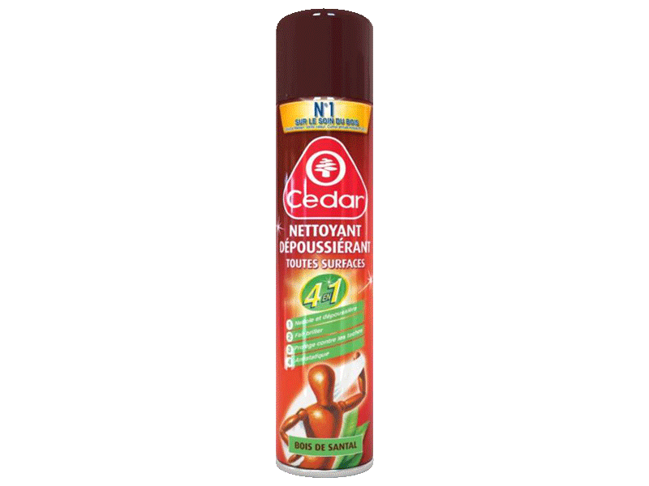

Détergeant / blanchisseur / dégraissant 🡺 cuisine, Salle de bain et Linge

Dégraissant / nettoyant / détartrant 🡺 Toutes surfaces (sauf sur bois vernis)

Dépoussiérant / agglutinant 🡺 bois vernis

**Dépoussiérage des sols, comment *vous* organisez vous sans gêner la personne aidée ?**



**Décrivez-moi les étapes :**

* Je fais les plaintes et le détourage en ramenant mes salissures au centre de la pièce
* Je passe un balayage à sec ou humide en commençant par le fond de la pièce pour finir vers l’entrée
* Si un objet me gêne, je le déplace et/ou je passe en dessous (coté)
* _ _ _ _ _ _ _ _ _ _ _ _ _ _ _ _ _ _ _ _ _ _ _ _ _ _ _ _ _ _ _ _ _ _ _ _ _ _ _ _ _ _ _ _ _ _ _ _ _ _ _ _ _ _ _ _ _ _ _
* _ _ _ _ _ _ _ _ _ _ _ _ _ _ _ _ _ _ _ _ _ _ _ _ _ _ _ _ _ _ _ _ _ _ _ _ _ _ _ _ _ _ _ _ _ _ _ _ _ _ _ _ _ _ _ _ _ _ _

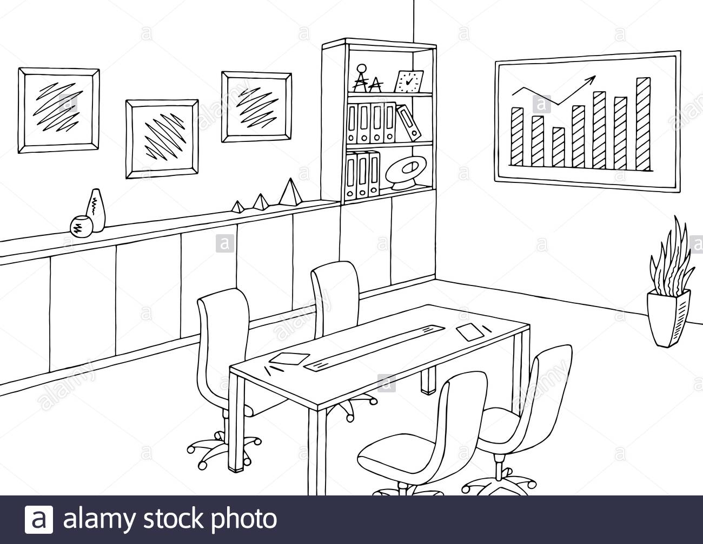**Vous devez faire l’entretien total de cette pièce comment vous organisez vous sans gêner la personne aidée ?**

**Décrivez-moi les étapes :**

* Je nettoie du plus propre au plus sale, de gauche à droite, tout dépend de l’aisance du professionnel
* Je nettoie les tableaux, l’étagère, de haut en bas, je déplace les objets pour nettoyer et je remets en place comme je les ai trouvés
* Je nettoie la partie plane du meuble et les porte en dernier
* Je nettoie la table et je fini par les chaises
* Je nettoie les sols

**Vous devez nettoyer cette salle de bain, comment vous organisez vous sans gêner la personne aidée ?**

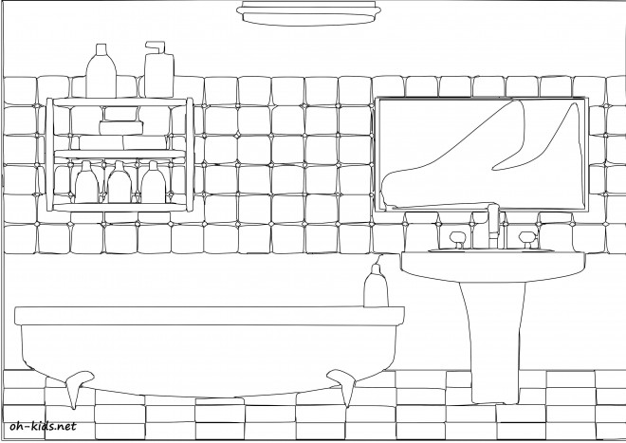

**Décrivez-moi les étapes :**

* Je commence toujours du plus propre au plus sale, de haut en bas et de gauche à droite ou inversement.
* Je commence à nettoyer le miroir au-dessus du lavabo, ensuite je dépoussière le meuble des produits de toilettes exposés.
* Avant de nettoyer le lavabo, je pulvérise du produit détartrant désinfectant dans la baignoire pour qu’elle soit plus facile à nettoyer.
* Je nettoie le lavabo et je lave le sol pour finir
* _ _ _ _ _ _ _ _ _ _ _ _ _ _ _ _ _ _ _ _ _ _ _ _ _ _ _ _ _ _ _ _ _ _ _ _ _ _ _ _ _ _ _ _ _ _ _ _ _ _ _ _ _ _ _ _ _ _ _

**Comment vous organisez vous pour nettoyer cette suite parentale sans gêner la personne aidée**

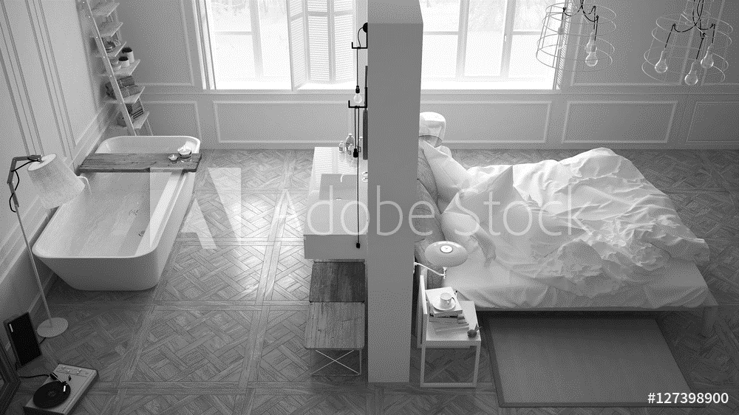

**Décrivez-moi les étapes :**

* J’arrive et j’aère la pièce
* J’ouvre le lit, pour l’aérer
* Je vais ensuite dans la salle de bain, je pulvérise de produit le lavabo + baignoire
* Je reviens dans la chambre pour retendre les draps
* Je retourne dans la salle de bain, pour nettoyer, lavabo, baignoire et meuble
* Je fini par les sols en commençant par la salle de bain jusqu’à la sortie de la chambre.
* Je referme les fenêtres

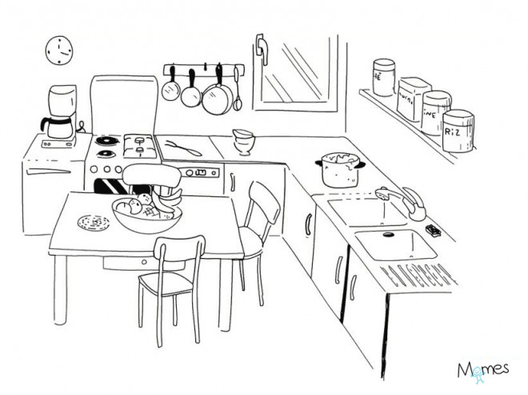**Vous devez entretenir la cuisine, comment vous organisez vous sans gêner la personne aidée ?**

**Décrivez-moi les étapes :**

* J’ouvre la fenêtre et j’aère la pièce et je commence toujours du plus propre au plus sale.
* Je pulvérise un produit dégraissant sur la gazinière, je laisse agir le temps de laver : «la vaisselle, l’étagère, la table, le plan de travail, la gazinière et je finis par l’évier ».
* Je nettoie les chaises et je les retourne sur la table pour faire les pieds et de pouvoir laver le sol sans gêne.
* Je lave les poignées de porte et je lave le sol de la cuisine.
* Je nettoie mon matériel et je le range
* _ _ _ _ _ _ _ _ _ _ _ _ _ _ _ _ _ _ _ _ _ _ _ _ _ _ _ _ _ _ _ _ _ _ _ _ _ _ _ _ _ _ _ _ _ _ _ _ _ _ _ _ _ _ _ _ _ _ _
* _ _ _ _ _ _ _ _ _ _ _ _ _ _ _ _ _ _ _ _ _ _ _ _ _ _ _ _ _ _ _ _ _ _ _ _ _ _ _ _ _ _ _ _ _ _ _ _ _ _ _ _ _ _ _ _ _ _ _
* _ _ _ _ _ _ _ _ _ _ _ _ _ _ _ _ _ _ _ _ _ _ _ _ _ _ _ _ _ _ _ _ _ _ _ _ _ _ _ _ _ _ _ _ _ _ _ _ _ _ _ _ _ _ _ _ _ _ _
* _ _ _ _ _ _ _ _ _ _ _ _ _ _ _ _ _ _ _ _ _ _ _ _ _ _ _ _ _ _ _ _ _ _ _ _ _ _ _ _ _ _ _ _ _ _ _ _ _ _ _ _ _ _ _ _ _ _ _

**Vous devez changer une ampoule, quelle précaution allez-vous prendre ?**

 **Décrivez votre action**

* Je vérifie que l’ampoule est bien à changer et je m’assure de bien couper le courant pour éviter tout risque d’électrocution.
* J’utilise un marche pied, ou un escabeau pas plus haut que deux marches
* Je prends la nouvelle ampoule, je monte les deux marches de l’escabeau, je retire l’ampoule à changer que je remplace par la nouvelle
* Je tiens l’ancienne ampoule dans mes mains, je descends doucement de l’escabeau, je remets le courant et je vérifie avec l’interrupteur que l’ampoule fonctionne. L’ampoule usager je la mets dans une boite pour la recyclerie

**Comment nettoyer le four micro-onde ?**

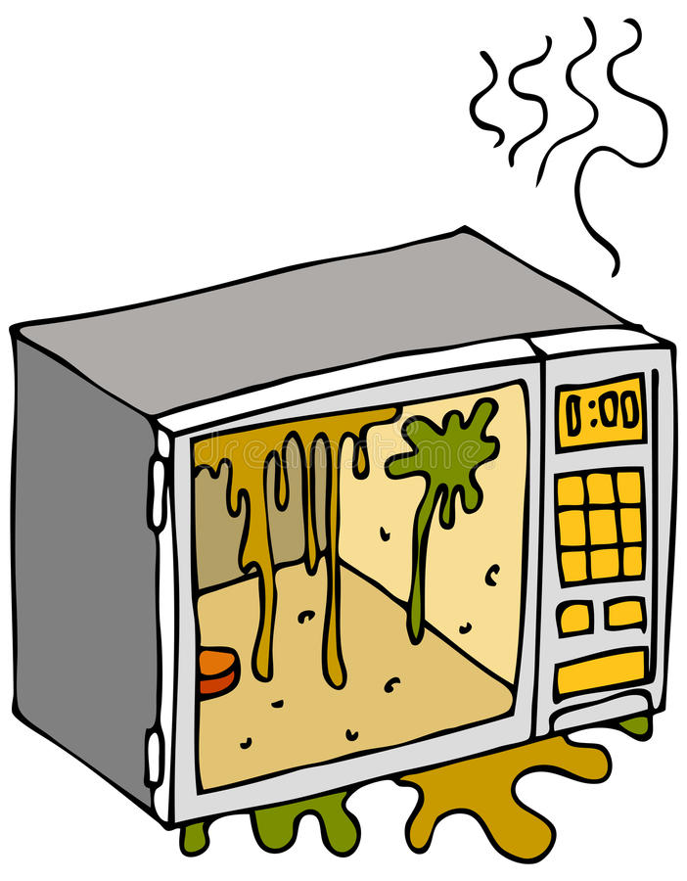**Décrivez votre action :**

* Je fais chauffer un bol d’eau pendant 3 à 4 mn et je laisse environ le même temps pour que la vapeur ramollisse les salissures.
* Je débranche le four micro-onde et j’ouvre la porte pour le vider de son plateau. Je le nettoie à l’eau et au savon dans la cuisine. Je le sèche.
* Je nettoie l’intérieur, haut, cotés, fond, bas. Je le rince, je l’essuie dans le même ordre. Je lave la porte intérieure, je rince, j’essuie. Je ferme

* Je fais l’extérieur du micro-onde, haut, coté, porte. Je nettoie les boutons et je fini par la poignée.
* Je me lave les mains, je remets le plateau et je le rebranche

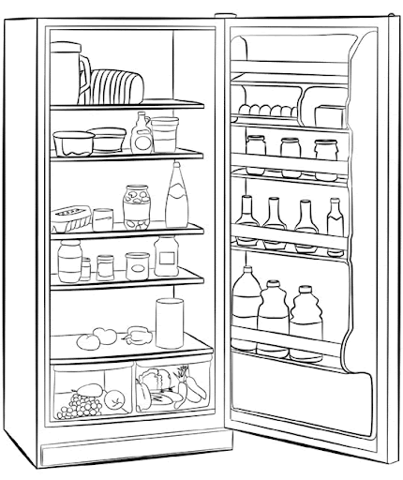**Vous devez nettoyer le réfrigérateur, comment faites-vous ?**

Remettre les clayettes et les étagères de la porte dans le réfrigérateur

Remettre l’alimentation dans le réfrigérateur

Remettre la roulette du réfrigérateur sur 3 et fermer la porte

Nettoyer le devant de la porte du réfrigérateur et les côtés du réfrigérateur

Finir par la poignet du réfrigérateur.

_ _ _ _ _ _ _ _ _ _ _ _ _ _ _ _ _ _ _ _ _ _ _ _ _ _ _ _ _ _ _ _ _ _ _ _ _ _ _ _ _ _ _ _ _ _ _ _ _ _ _ _ _ _ _ _ _ _ _ _ _ _ _ _ _

_ _ _ _ _ _ _ _ _ _ _ _ _ _ _ _ _ _ _ _ _ _ _ _ _ _ _ _ _ _ _ _ _ _ _ _ _ _ _ _ _ _ _ _ _ _ _ _ _ _ _ _ _ _ _ _ _ _ _ _ _ _ _ _ _

_ _ _ _ _ _ _ _ _ _ _ _ _ _ _ _ _ _ _ _ _ _ _ _ _ _ _ _ _ _ _ _ _ _ _ _ _ _ _ _ _ _ _ _ _ _ _ _ _ _ _ _ _ _ _ _ _ _ _ _ _ _ _ _ _

**Votre réponse :**

* Retirer et trier l’alimentation (produits périmés et/ou invariés)
* Mettre la roulette sur zéro et retirer les clayettes et les étagères de la porte
* Nettoyer les clayettes et les étagères de la porte
* Avec une lavette et une bassine d’eau tempéré et du produit multi usage (vinaigre blanc), mettre une serviette, un chiffon en bas du réfrigérateur avant de commencer. Laver de haut en bas dans le réfrigérateur en partant de l’intérieur à l’extérieur.
* Laver les parois du réfrigérateur en partant de l’intérieur vers l’extérieur
* Nettoyer la porte du réfrigérateur en faisant le détourage et ensuite des mouvements en S ou en 8
* Nettoyer le contour intérieur du réfrigérateur

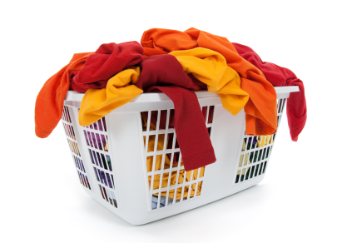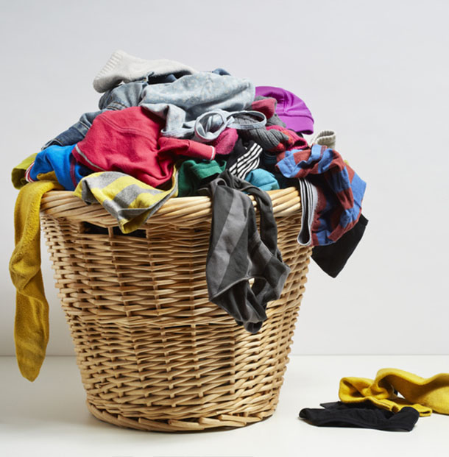

**Vous triez le linge, à quoi devez-vous faire attention, qu’est-ce qui vous permet de faire le tri correctement ?**

* Couleur, matière, température
* La quantité doit être prioritaire, (sauf à la demande de la personne aidée
* Je ferme les boutons des chemises et des fermetures éclaires des pantalons
* Vérifier les poches des chemises et des pantalons
* Je les mets un à un dans la machine à laver
* Je mets le produit nécessaire pour la tourner
* Je choisi le programme adéquat pour la tourner
* Je ferme la porte, je vérifie les organes vitaux (Connection à l’eau et à l’électricité)

**Selon les pictogrammes représentés, à quelle action correspondent-ils ?**



**Votre réponse :**

Blanchisseur

**Votre réponse :**

Lavage en machine à 30°C



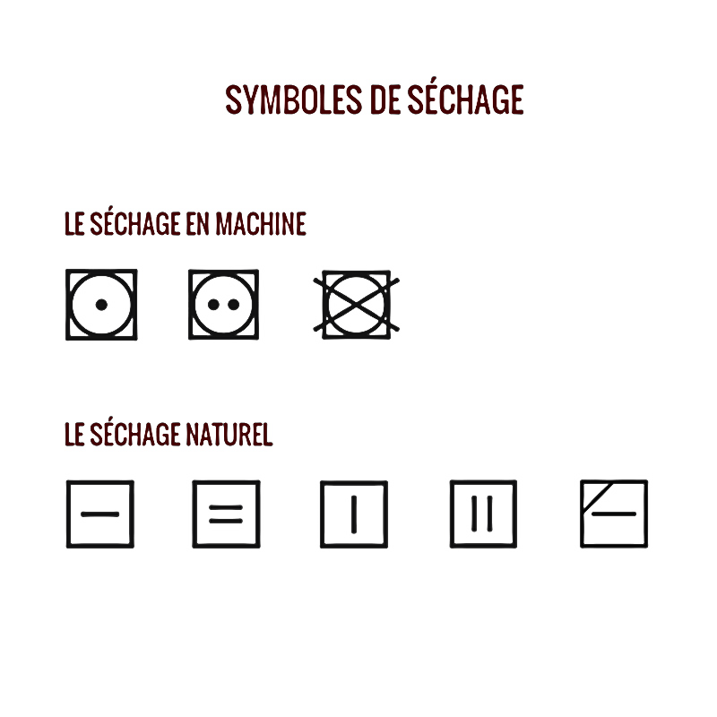

**Votre réponse :**

Séchage à plat

**Votre réponse :**

Lavage à la main

**Votre réponse :**

Sèche-linge à 60°C



**Votre réponse :**

À froid 110°C

Moyen 150°C

À Chaud 210°C

**Quand il y a une croix sur le symbole qu’est-ce que cela signifie X ? Interdiction**

**Expliquer le lavage des mains et en combien de temps ?**



**Votre réponse :**

Se mouiller les mains

Prendre une dose nécessaire de savon

Faire mousser le savon entre ses mains

Frotter les mains, le dos des mains, entre les doigts, les ongles, le creux des mains, les pousser, les poignets.

Rincer sans revenir

Sécher les mains avec une serviette propre et sèche

Se laver les mains pendant 1 minute



Se laver les mains apporte une sécurité hygiénique pour l’ADVF et la Personne Aidée.

Il faut se laver les mains, avant, pendant et après chaque intervention.

La contamination se fait par manu-porter

_ _ _ _ _ _ _ _ _ _ _ _ _ _ _ _ _ _ _ _ _ _ _ _ _ _ __ _ _ _ _ _ _ _ _ _ _ _ _ _ _ _ _ _ _ _ _ _ _ _ _ _ _ _ _ _ _ _ _ _ _ _ _ _ _ _ _ _ _ _ _ _ _ _ _ _ _ _ _ _ _ _ _ _ _ _ __ _ _ _ _ _ _ _ _ _ _ _ _ _ _ _ _ _ _ _ _ _ _ _ _ _ _ _ _ _ _ _ _ _ _ _ _ _ _ _ _ _ _ _ _ _ _ _ _ _ _ _ _ _ _ _ _ _ _ _ __ _ _ _ _ _ _ _ _ _ _ _ _ _ _ _ _ _ _ _ _ _ _ _ _ _ _ _ _ _ _ _ _ _ _ _ _ _ _ _ _ _ _ _ _ _ _ _ _ _ _ _ _ _ _ _ _ _ _ _ __ _ _ _ _ _ _ _ _ _ _ _ _ _ _ _ _ _ _ _ _ _ _ _ _ _ _ _ _ _ _ _ _ _ _ _ _ _ _ _ _ _ _ _ _ _ _ _ _ _ _ _ _ _ _ _ _ _ _ _ __ _ _ _ _ _ _ _ _ _ _ _ _ _ _ _ _ _ _ _ _ _ _ _ _ _ _ _ _ _ _ _ _ _ _ _ _ _ _ _ _ _ _ _ _ _ _ _ _ _ _ _ _ _ _ _ _ _ _ _ __ _ _ _ _ _ _ _ _ _ _ _ _ _ _ _ _ _ _ _ _ _ _ _ _ _ _ _ _ _ _ _ _ _ _ _ _ _ _ _ _ _ _ _ _ _ _ _ _ _ _ _ _ _ _ _ _ _ _ _ __ _ _ _ _ _ _ _ _ _ _ _ _ _ _ _ _ _ _ _ _ _ _ _ _ _ _ _ _ _ _ _ _ _ _ _ _ _ _ _ _ _ _ _ _ _ _ _ _ _ _ _ _ _ _ _ _ _ _ _ __ _ _ _ _ _ _ _ _ _ _ _ _ _ _ _ _ _ _ _ _ _ _ _ _ _ _ _ _ _ _ _ _ _ _ _ _ _ _ _ _ _ _ _ _ _ _ _ _ _ _ _ _ _ _ _

|  |
| --- |
|  |
|  |
|  |
|  |
|  |
|  |
|  |
|  |

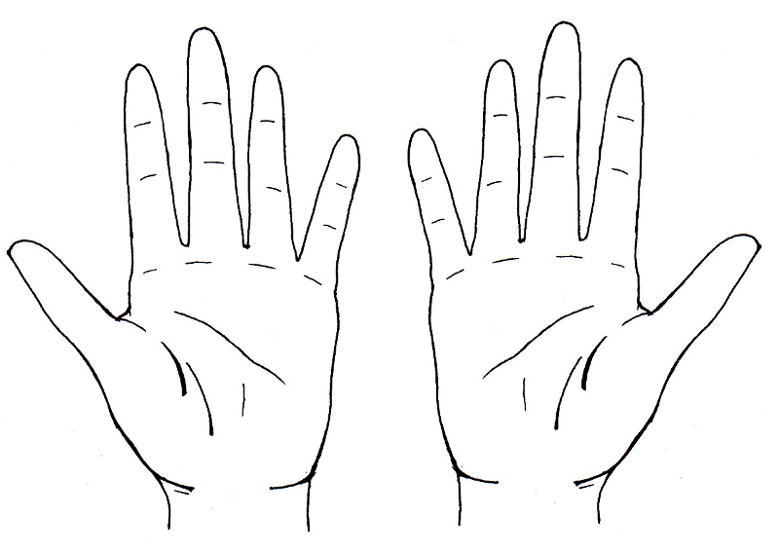**Vous, vous lavez les mains, que ne devez-vous pas porter ?**

|  |
| --- |
| * Bague |
| * Montre |
| * Bracelet |
| * Montre |
| * Vernis à ongle |
| * Ongle long |
|  |

Définissez le rôle de l’Assistant(e) De Vie aux Familles lors de son intervention au domicile de la personne aidée

Le rôle de l’ADVF est d’apporter une aide ponctuelle ou permanente au domicile de la personne Aidée. Elle intervient dans les situations d’handicap, de vieillissement, de maladie ou simplement de personne dites fragilisé. L’ADVF intervient aussi au domicile des enfants pour relayer les parents dans la prise en charge de leur enfant.

_ _ _ _ _ _ _ _ _ _ _ _ _ _ _ _ _ _ _ _ _ _ _ _ _ _ _ _ _ _ _ _ _ _ _ _ _ _ _ _ _ _ _ _ _ _ _ _ _ _ _ _ _ _ _ _ _ _ _ _ _ _ _ _ _

_ _ _ _ _ _ _ _ _ _ _ _ _ _ _ _ _ _ _ _ _ _ _ _ _ _ _ _ _ _ _ _ _ _ _ _ _ _ _ _ _ _ _ _ _ _ _ _ _ _ _ _ _ _ _ _ _ _ _ _ _ _ _ _ _

Lors de votre première intervention, vous rencontrez pour la première fois la personne aidée, que devez-vous faire ?

Se présenter Nom / Prénom

S’assurer de l’identité de la personne

Présenter son employeur

Définir sa mission en posant le cadre

Établir une relation de confiance

Demander à la personne ces priorités

Consulter le cahier de liaison

Vous demandez à la personne ou vous pouvez déposer vos affaires

Demander ou se laver les mains (quel savon prendre et quelle serviette utiliser)

On met sa tenue professionnelle

On demande ou son rangé les produits et on fait un état des lieux de la pièce

_ _ _ _ _ _ _ _ _ _ _ _ _ _ _ _ _ _ _ _ _ _ _ _ _ _ _ _ _ _ _ _ _ _ _ _ _ _ _ _ _ _ _ _ _ _ _ _ _ _ _ _ _ _ _ _ _ _ _ _ _ _ _ _ _

_ _ _ _ _ _ _ _ _ _ _ _ _ _ _ _ _ _ _ _ _ _ _ _ _ _ _ _ _ _ _ _ _ _ _ _ _ _ _ _ _ _ _ _ _ _ _ _ _ _ _ _ _ _ _ _ _ _ _ _ _ _ _ _ _

_ _ _ _ _ _ _ _ _ _ _ _ _ _ _ _ _ _ _ _ _ _ _ _ _ _ _ _ _ _ _ _ _ _ _ _ _ _ _ _ _ _ _ _ _ _ _ _ _ _ _ _ _ _ _ _ _ _ _ _ _ _ _ _ _

_ _ _ _ _ _ _ _ _ _ _ _ _ _ _ _ _ _ _ _ _ _ _ _ _ _ _ _ _ _ _ _ _ _ _ _ _ _ _ _ _ _ _ _ _ _ _ _ _ _ _ _ _ _ _ _ _ _ _ _ _ _ _ _ _

Quand on parle d’organisation, comment allez-vous faire pour optimiser le temps que vous allez passer chez la personne aidée ?

J’élabore un planning avec la personne aidée

J’optimise mon travail en préparant mon matériel en amont, avant de commencer ma tâche

Je commence du propre au plus sale en respectant un ordre bien défini

_ _ _ _ _ _ _ _ _ _ _ _ _ _ _ _ _ _ _ _ _ _ _ _ _ _ _ _ _ _ _ _ _ _ _ _ _ _ _ _ _ _ _ _ _ _ _ _ _ _

_ _ _ _ _ _ _ _ _ _ _ _ _ _ _ _ _ _ _ _ _ _ _ _ _ _ _ _ _ _ _ _ _ _ _ _ _ _ _ _ _ _ _ _ _ _ _ _ _ _

_ _ _ _ _ _ _ _ _ _ _ _ _ _ _ _ _ _ _ _ _ _ _ _ _ _ _ _ _ _ _ _ _ _ _ _ _ _ _ _ _ _ _ _ _ _ _ _ _ _

_ _ _ _ _ _ _ _ _ _ _ _ _ _ _ _ _ _ _ _ _ _ _ _ _ _ _ _ _ _ _ _ _ _ _ _ _ _ _ _ _ _ _ _ _ _ _ _ _ _

_ _ _ _ _ _ _ _ _ _ _ _ _ _ _ _ _ _ _ _ _ _ _ _ _ _ _ _ _ _ _ _ _ _ _ _ _ _ _ _ _ _ _ _ _ _ _ _ _ _

Que doit faire en priorité l’Assistant(e) De Vie aux Familles, qu’elle est sa première action professionnelle pour pouvoir garder le lien entre vous et les autres intervenant ?

Le cahier de liaison permet de garder le lien entre l’ADVF et les autres intervenant

La communication se fait directement à l’oral

La communication se fait indirectement (téléphone et à l’écrit)

_ _ _ _ _ _ _ _ _ _ _ _ _ _ _ _ _ _ _ _ _ _ _ _ _ _ _ _ _ _ _ _ _ _ _ _ _ _ _ _ _ _ _ _ _ _ _ _ _ _

_ _ _ _ _ _ _ _ _ _ _ _ _ _ _ _ _ _ _ _ _ _ _ _ _ _ _ _ _ _ _ _ _ _ _ _ _ _ _ _ _ _ _ _ _ _ _ _ _ _

_ _ _ _ _ _ _ _ _ _ _ _ _ _ _ _ _ _ _ _ _ _ _ _ _ _ _ _ _ _ _ _ _ _ _ _ _ _ _ _ _ _ _ _ _ _ _ _ _ _

_ _ _ _ _ _ _ _ _ _ _ _ _ _ _ _ _ _ _ _ _ _ _ _ _ _ _ _ _ _ _ _ _ _ _ _ _ _ _ _ _ _ _ _ _ _ _ _ _ _

_ _ _ _ _ _ _ _ _ _ _ _ _ _ _ _ _ _ _ _ _ _ _ _ _ _ _ _ _ _ _ _ _ _ _ _ _ _ _ _ _ _ _ _ _ _ _ _ _ _

_ _ _ _ _ _ _ _ _ _ _ _ _ _ _ _ _ _ _ _ _ _ _ _ _ _ _ _ _ _ _ _ _ _ _ _ _ _ _ _ _ _ _ _ _ _ _ _ _ _

_ _ _ _ _ _ _ _ _ _ _ _ _ _ _ _ _ _ _ _ _ _ _ _ _ _ _ _ _ _ _ _ _ _ _ _ _ _ _ _ _ _ _ _ _ _ _ _ _ _

_ _ _ _ _ _ _ _ _ _ _ _ _ _ _ _ _ _ _ _ _ _ _ _ _ _ _ _ _ _ _ _ _ _ _ _ _ _ _ _ _ _ _ _ _ _ _ _ _ _

_ _ _ _ _ _ _ _ _ _ _ _ _ _ _ _ _ _ _ _ _ _ _ _ _ _ _ _ _ _ _ _ _ _ _ _ _ _ _ _ _ _ _ _ _ _ _ _ _ _

_ _ _ _ _ _ _ _ _ _ _ _ _ _ _ _ _ _ _ _ _ _ _ _ _ _ _ _ _ _ _ _ _ _ _ _ _ _ _ _ _ _ _ _ _ _ _ _ _ _

Quel est l’outil à consulter et qui vous permettra de pouvoir organiser votre intervention ?

Le cahier de liaison

_ _ _ _ _ _ _ _ _ _ _ _ _ _ _ _ _ _ _ _ _ _ _ _ _ _ _ _ _ _ _ _ _ _ _ _ _ _ _ _ _ _ _ _ _ _ _ _ _ _

Quelle est la tenue qu’un(e) Assistant(e) De Vie aux Familles doit avoir pour exercer son métier ?

**À l’aide du dessin, donner lui une tenue professionnelle ADVF.**

**Attention cela passe par les cheveux jusqu’aux pieds**

**N’oubliez pas les mains**

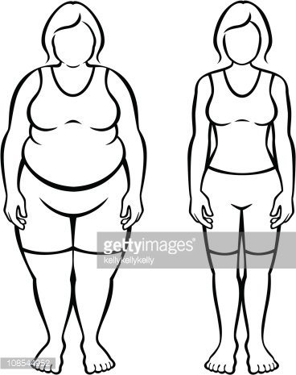

Cheveux longs, ‘se les attacher’

Porter une tenue correcte, une veste

Un pantalon de travail une tenue correcte

Une paire de chaussure confortable, voir des sur chaussures

Une paire de gant à usage unique

Un masque

Une charlotte

Un tablier jetable

_ _ _ _ _ _ _ _ _ _ _ _ _ _ _ _ _ _ _ _ _ _ _ _ _ _ _ _ _ _ _ _ _ _ _ _ _ _ _ _ _ _ _ _ _ _ _ _ _

_ _ _ _ _ _ _ _ _ _ _ _ _ _ _ _ _ _ _ _ _ _ _ _ _ _ _ _ _ _ _ _ _ _ _ _ _ _ _ _ _ _ _ _ _ _ _ _ _ _

Quels sont les principaux savoir / savoir-faire et savoir-être, qu’un(e) Assistant(e) De Vie aux Familles doit posséder pour exercer ce métier ?

-- Savoir / savoir faire

- Accompagner - Prendre des rendez-vous / remplir des documents administratif-

- Écouter - Être attentif à la Personne Aidée

- Comprendre - Répondre aux attentes de la Personne Aidée

- Agir - Rester calme dans les situations d’urgences

- Informer - Savoir à qui s’adresser

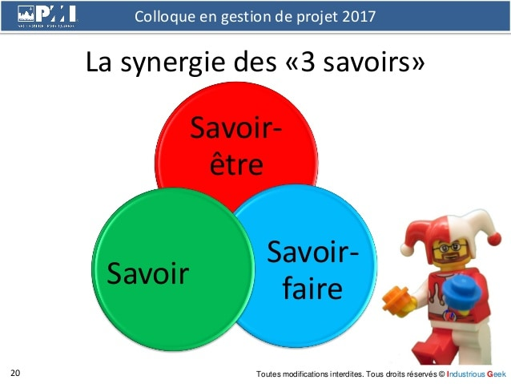

- Savoir - être

- Souriant

- Aimable

- Respectueux

- Poli

- Propre

- Patient

- communicatif

- empathique

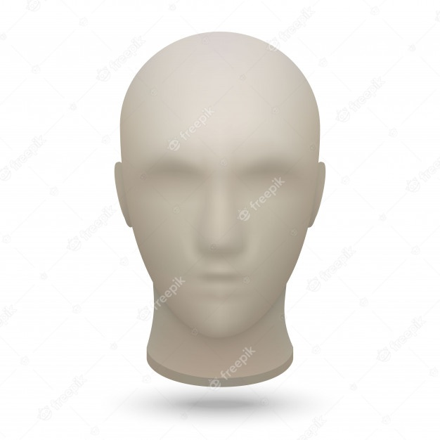Selon vous, qu’elle expression du visage devons-nous avoir auprès de la personne aidée ?

Aidez-vous d’un crayon de papier et dessinez le visage de l’ADVF que vous voulez être.

À quelles fréquences devez-vous réaliser les tâches suivantes ?

|  |  |  |  |  |  |
| --- | --- | --- | --- | --- | --- |
| TACHES | **Tous les jours** | **1 à 2 fois / semaine** | **Tous les 15 jours** | **Tous les mois** | **1 à 2 fois / an** |
| **Le micro-onde** |  | **X** |  |  |  |
| **Réfrigérateur** |  |  | **X** | **X** |  |
| **Réfection du lit** | **X** |  |  |  |  |
| **Nettoyer toutes les vitres** |  |  |  | **X** |  |
| **Nettoyer les moquettes avec un Shampooing** |  |  |  |  | **X** |
| **Enlever le calcaire dans la cuisine**  **et la salle de bain** |  | **X** |  |  |  |
| **Dépoussiérer les meubles** |  | **X** |  |  |  |
| **Faire la vaisselle** | **X** |  |  |  |  |
| **Laver les rideaux** |  |  |  |  | **X** |

Citez deux actions à réaliser en fin d’intervention.

Ranger le matériel

_ _ _ _ _ _ _ _ _ _ _ _ _ _ _ _ _ _ _ _ _ _ _ _ _ _ _ _ _ _ _ _ _ _ _ _ _ _ _ _ _ _ _ _ _ _ _ _ _ _

Remplir le cahier de liaison

_ _ _ _ _ _ _ _ _ _ _ _ _ _ _ _ _ _ _ _ _ _ _ _ _ _ _ _ _ _ _ _ _ _ _ _ _ _ _ _ _ _ _ _ _ _ _ _ _ _ _

Avec les produits d’entretien suivant, quel est son utilité et quelle est son action recherchée ?

1. Produit à vitre : Détergeant qui décolle les salissures et fait briller _ _ _ _ _ _ _ _ _ _ _ _ _ _ _ _ _ _ _ _ _ _ _ _ _ _ _ _ _ _ _ _ _ _ _ _ _ _ _ _ _ _ _ _ _ _ _ _ _ _ _ _ _ _ _ _ _ _ _ _ _
2. Le Bec verseur pour Toilette : Détergeant, désinfectant, détartrant _ _ _ _ _ _ _ _ _ _ _ _ _ _ _ _ _ _ _ _ _ _ _ _ _ _ _ _ _ _ _ _ _ _ _ _ _ _ _ _ _ _ _ _ _ _ _ _ _ _ _ _ _ _ _ _ _ _ _ _ _
3. Produit pour ameublement donnant et recevant de l’eau : Détartrant _ _ _ _ _ _ _ _ _ _ _ _ _ _ _ _ _ _ _ _ _ _ _ _ _ _ _ _ _ _ _ _ _ _ _ _ _ _ _ _ _ _ _ _ _ _ _ _ _ _ _ _ _ _ _ _ _ _ _
4. Ameublement des WC de la Salle de Bain, cuisine etc… ils ont tous un produit en commun le quel ? Détartrant, désinfectant _ _ _ _ _ _ _ _ _ _ _ _ _ _ _ _ _ _ _ _ _ _ _ _ _ _ _ _ _ _ _ _
5. Chaise percé, lit, matelas à langer, bassine etc… ils ont tous le même produit le quel ? Désinfectant _ _ _ _ _ _ _ _ _ _ _ _ _ _ _ _ _ _ _ _ _ _ _ _ _ _ _ _ _ _ _ _ _ _ _ _ _ _ _ _ _ _ _ _ _ _ _ _ _ _ _ _ _
6. Table de cuisson, gazinière, plat etc… ils ont tous le même produit le quel ? Dégraissant _ _ _ _ _ _ _ _ _ _ _ _ _ _ _ _ _ _ _ _ _ _ _ _ _ _ _ _ _ _ _ _ _ _ _ _ _ _ _ _ _ _ _ _ _ _ _ _ _ _ _ _ _ _ _ _ _ _ _

Quelles sont les précautions que vous devez prendre lors de l’utilisation des produits ménagers ?

Porter des gans

Ne pas inhaler

Ne pas en projeter sur les yeux

Ne pas mélanger les produits

Se protéger la peau (tablier)

Prévenir la personne

Lire le mode d’emploi avant toute manipulation

Quelles sont les deux pièces de la maison, où il y a beaucoup de micro-organismes ?

Les toilettes

La salle de bain

Ouvrir les fenêtres permet ?

D’aérer la pièce

Renouveler l’air

Éviter la prolifération des micro-organismes

_ _ _ _ _ _ _ _ _ _ _ _ _ _ _ _ _ _ _ _ _ _ _ _ _ _ _ _ _ _ _ _ _ _ _ _ _ _ _ _ _ _ _ _ _ _ _ _ _

À quels risques devez-vous faire attention lorsque vous aérer les pièces ?

Na pas laisser les fenêtres trop longtemps ouvertes

Faire attention aux saisons

Faire attention au temps

Faire attention aux nuisances

Faire attention aux enfants (risque de défenestration)

Attention au pincement lors de la fermeture des fenêtres

_ _ _ _ _ _ _ _ _ _ _ _ _ _ _ _ _ _ _ _ _ _ _ _ _ _ _ _ _ _ _ _ _ _ _ _ _ _ _ _ _ _ _ _ _ _ _ _ _

